Book Return Kiosk User Guide

Staff and students will now be able to return the books conveniently via the Book Return Kiosk which is located on your left once you enter the library. All the instructions are provided on the screen. Please be sure to read the instructions as you move from screen to screen.

Step 1: Before starting any transaction keep your items far from the shutter. Select ‘START’ button to begin your transaction.

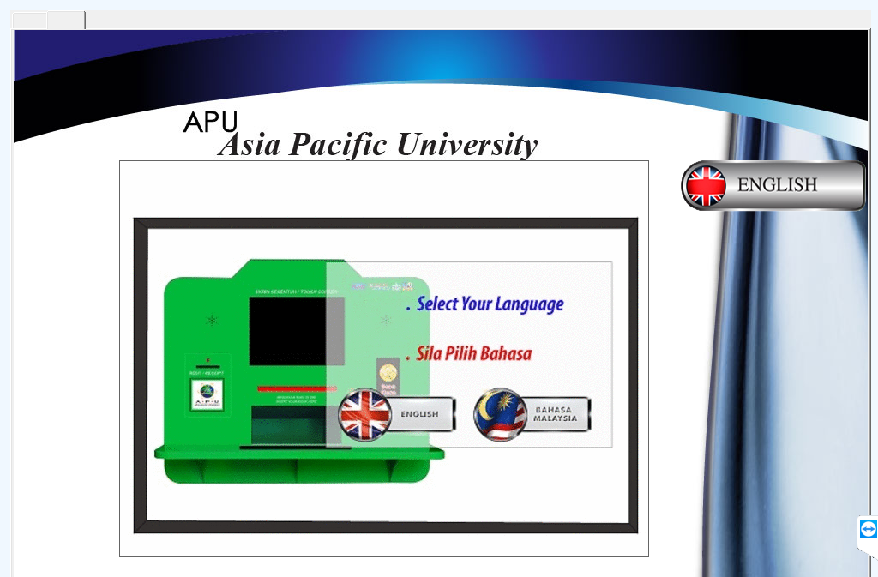

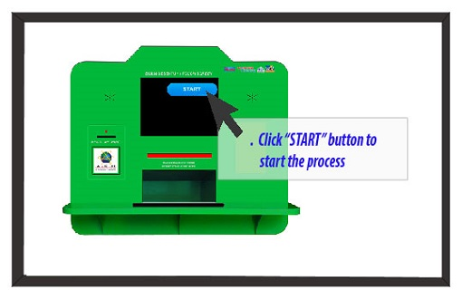

Step 2: Please place only one book at a time on the pad and you will see the book details such as the title, author, etc. are displayed on the screen.

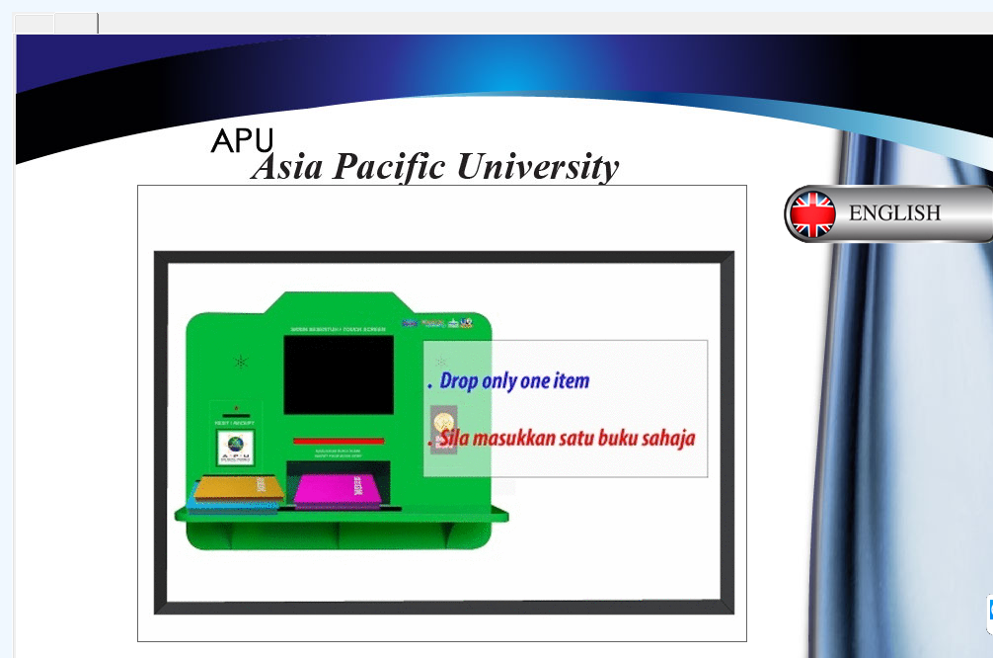

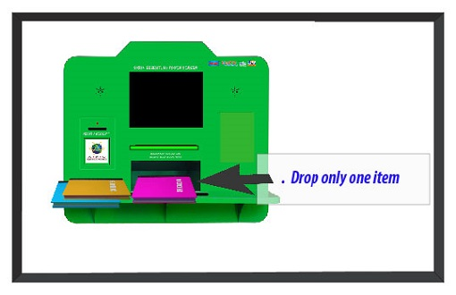

- As the shutter opens to receive the book that you have placed on the pad, you will need to drop the book and wait for few minutes for the kiosk to complete the transaction.

- Once the book is dropped, shutter will close and the transaction is completed. The shutter will automatically open after the first transaction to allow you to drop if you have more than one book to return. You will need to repeat step 1 and 2 if you have more books to return.

- If you would like to finish your transaction, go back to the main screen and select the “END” button.

- Press the “END” button to finish the transaction. You will receive a printout of ‘ITEM RETURN RECEIPT’ from the kiosk that will have the summary of your transactions (as shown below):

IMPORTANT REMINDER: Please remember to check your student webmail / staff email to ensure you have received the email notification for the transactions you have performed. Please contact us at library@staffemail.apu.edu.my immediately if you have not received the notifications.

